**New York City Arrests**

**Talend- SCREENSHOTS**

**Group 4**

Fct_nycarrests- 152639 rows

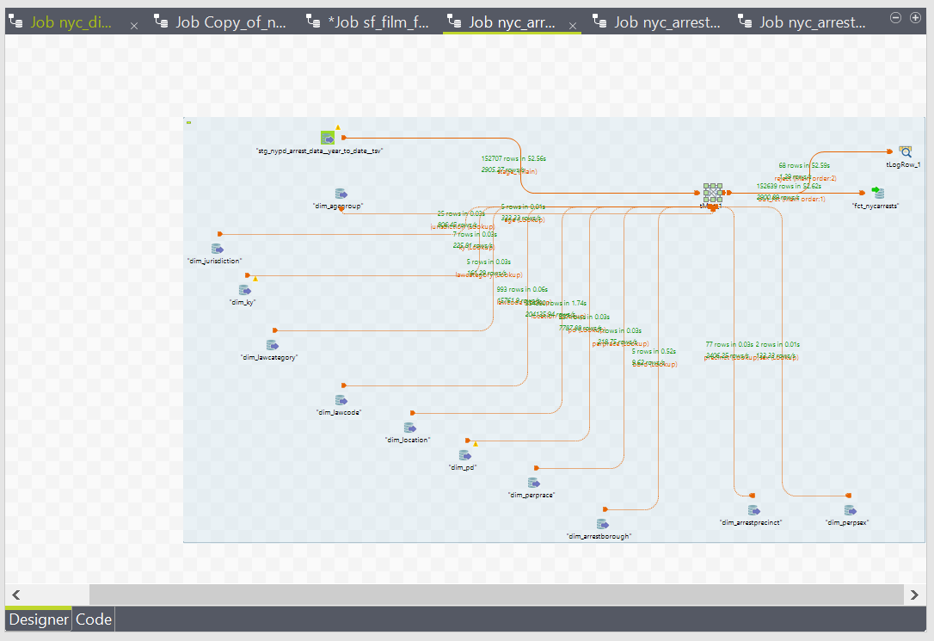

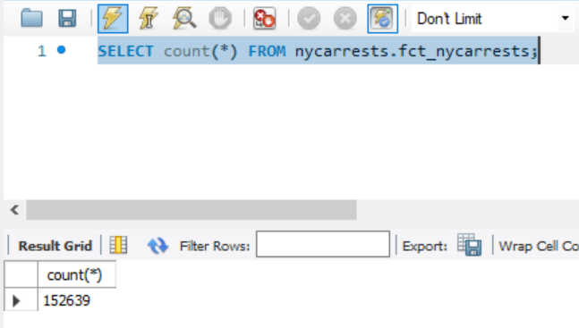

Dim_pd- 257 rows

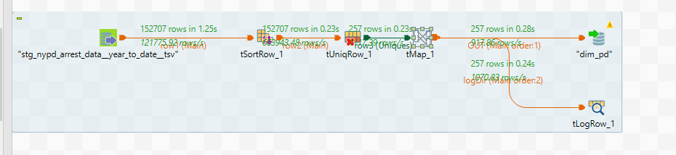

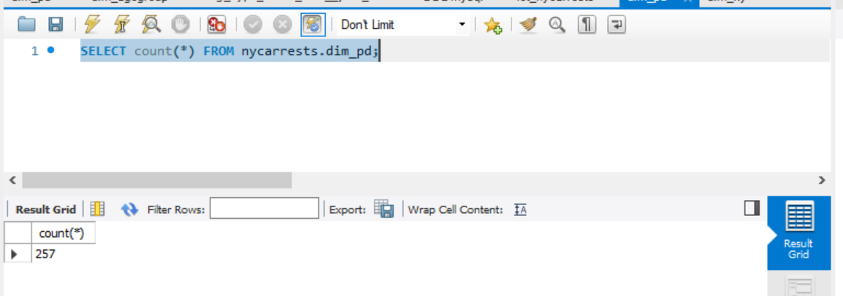

Dim_agegroup- 5 rows

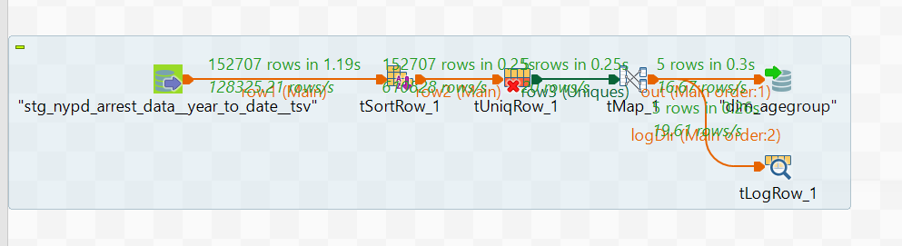

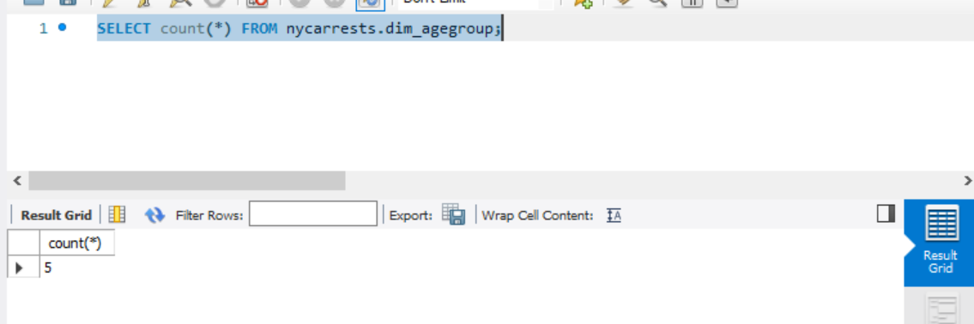

Dim_arrestborough- 5 rows

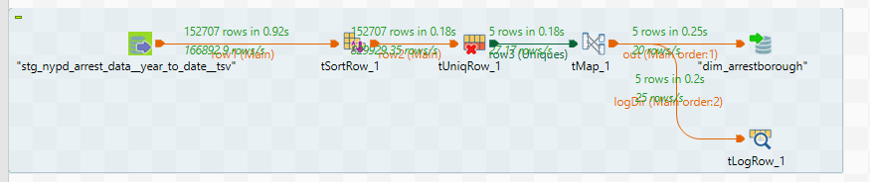

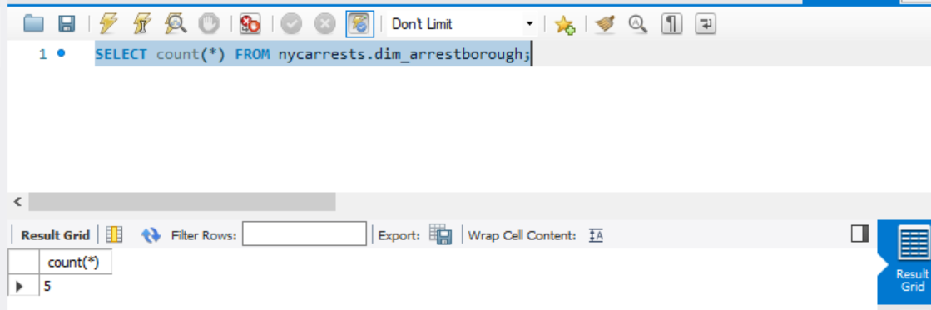

Dim_arrestprecinct- 77 rows

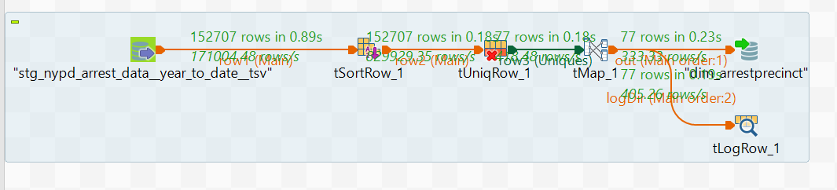

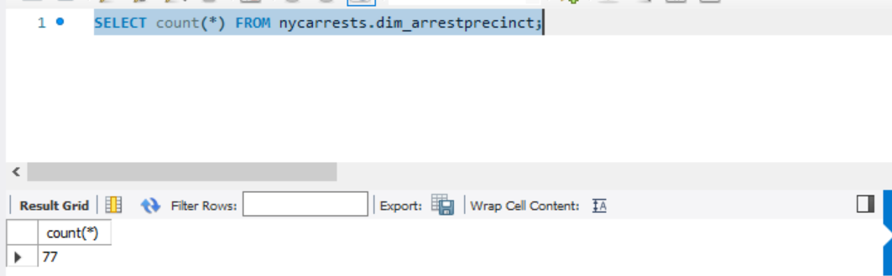

Dim_jurisdiction- 25 rows

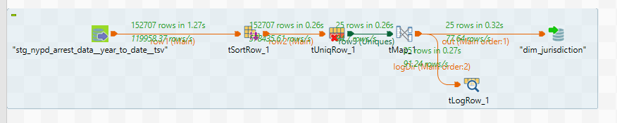

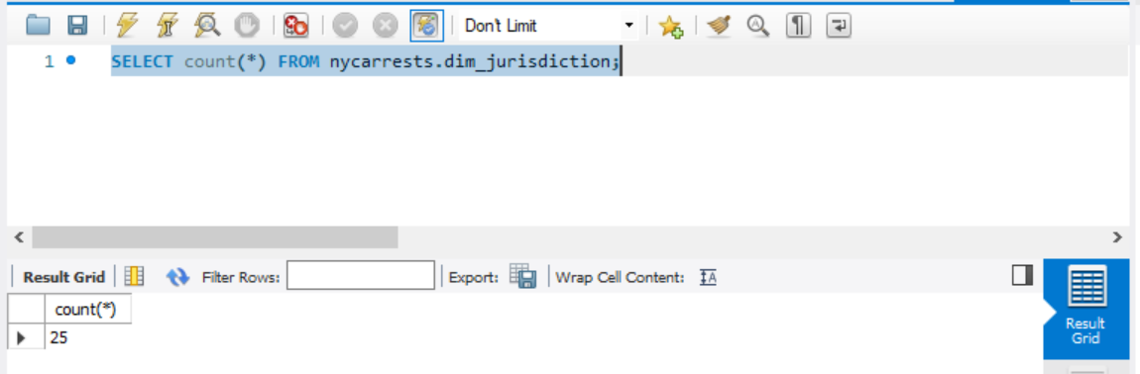

Dim_ky- 7 rows

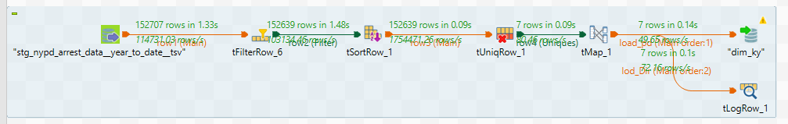

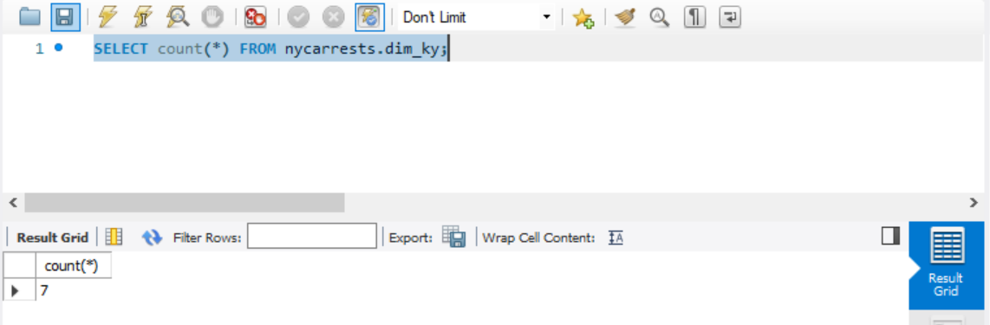

Dim-lawcategory- 5 rows

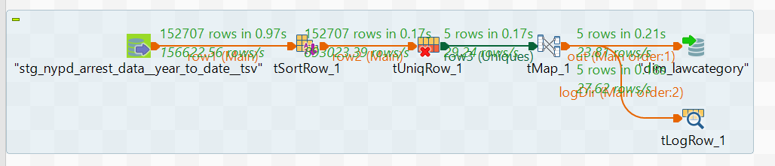

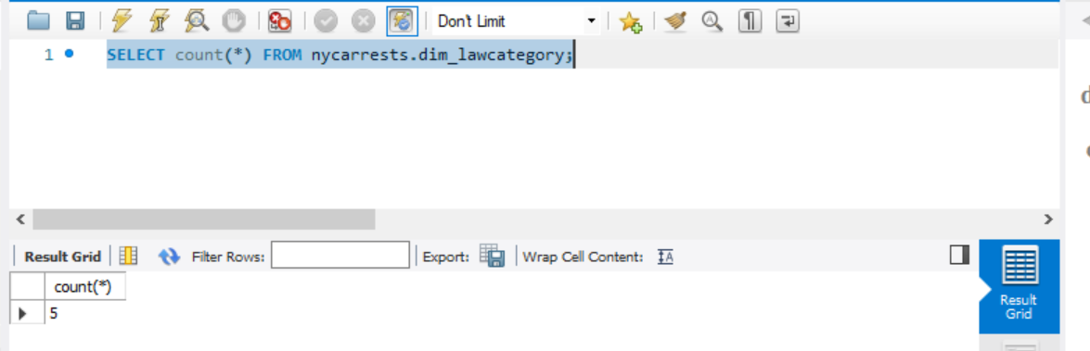

Dim_lawcode- 993 rows

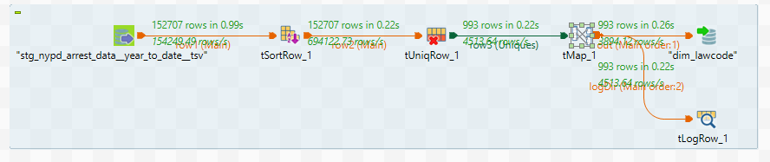

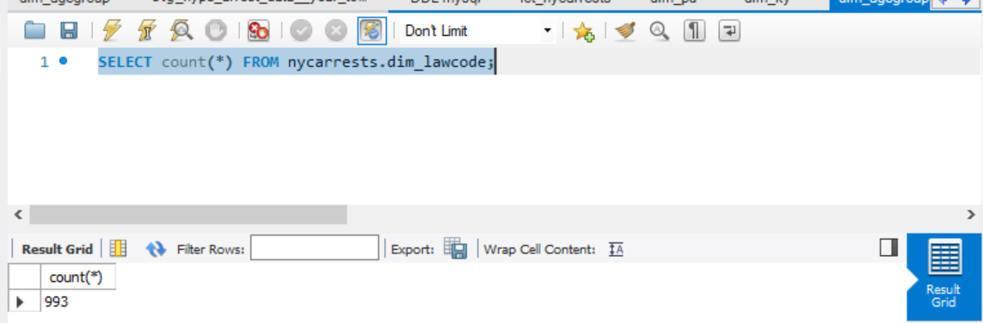

dim_location- 33891 rows

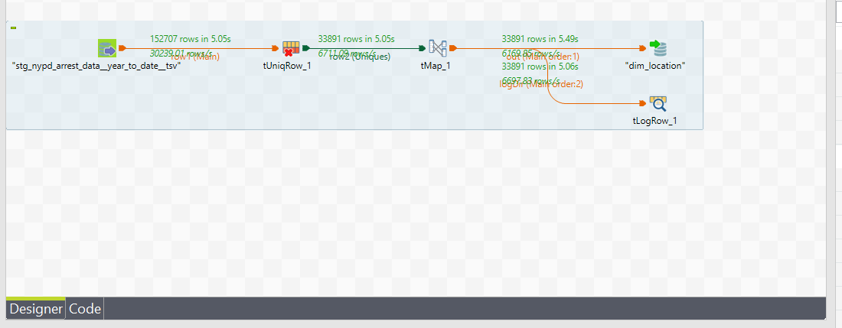

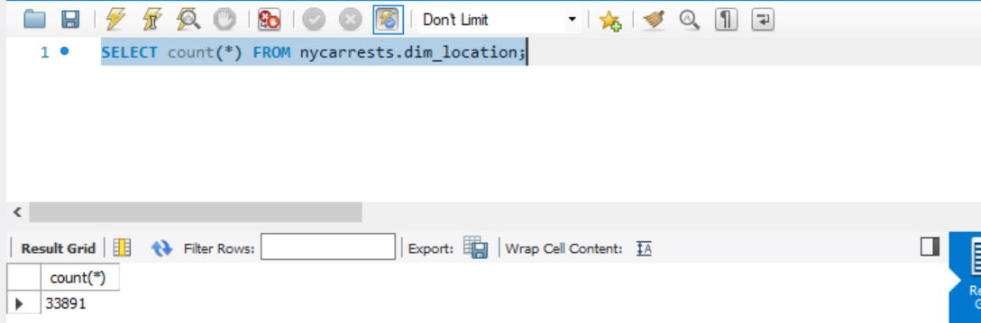

Dim_perprace- 7 rows

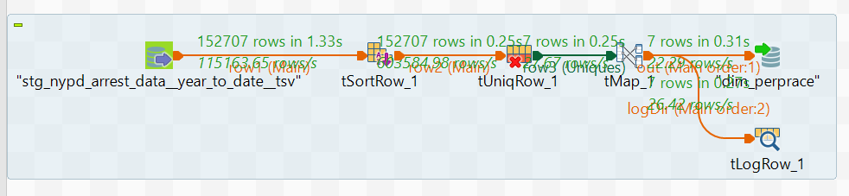

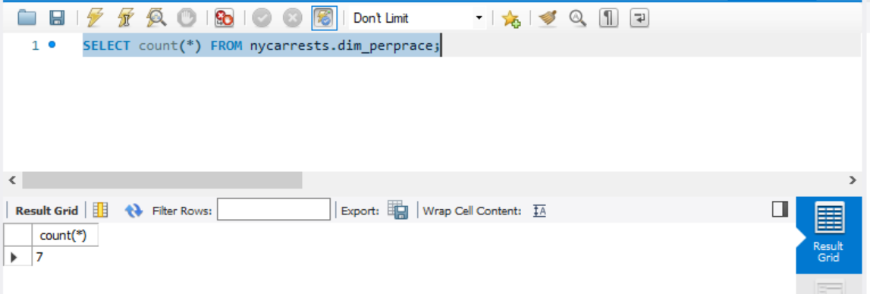

Dim_perpsex- 2 rows

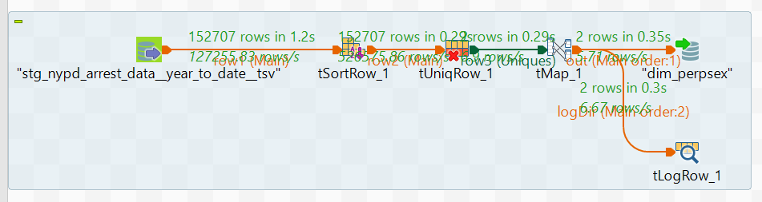

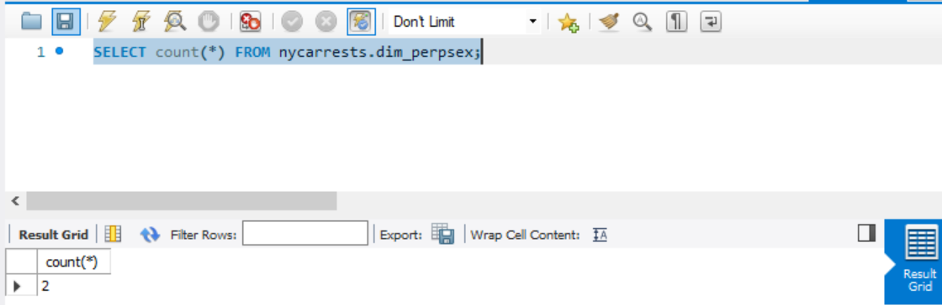

Staging file- 155707 rows

